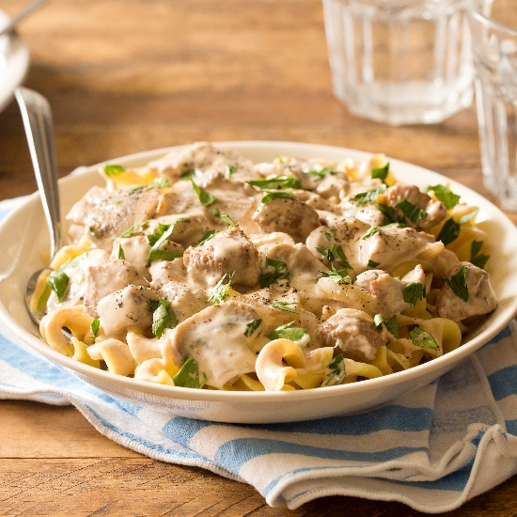
Veal Stroganoff
by Carla Cardello (www.carlacardello.com)

Makes 4 servings

Marinate Time: 8 hours or overnight
Prep Time: 15 minutes
Cook Time: 30 minutes
Total Time: 8 hours, 45 minutes

Ingredients
Marinade
- 1/2 pound boneless veal stew meat, cut into 1/2-inch pieces
- 1/4 cup olive oil
- 1 1/2 tablespoons fresh lemon juice
- 1 tablespoon white distilled vinegar
- 1 teaspoon Worcestershire sauce
- 1/2 teaspoon dry mustard
- 1/2 teaspoon salt
- 1/4 teaspoon paprika
- 1/4 teaspoon ground black pepper

Stroganoff
- 6 ounces wide egg noodles
- 1 tablespoon all-purpose flour
- 1 teaspoon vegetable oil
- Half a small onion, sliced
- 4 large white button mushrooms, sliced
- 1 clove garlic, minced
- 1 tablespoon flour
- 1 cup beef broth
- 1/2 teaspoon salt plus more for seasoning
- 1/4 cup full-fat sour cream
- 1 teaspoon Worcestershire sauce
- 1 tablespoon fresh chopped parsley

Instructions

- Add the veal to a container with a lid or a plastic zip-top bag.
- For the marinade: Whisk together the olive oil, lemon juice, vinegar, Worcestershire sauce, mustard, salt, paprika, and black pepper. Pour over the meat. Cover and refrigerate at least 8 hours or overnight.
- Bring a large pot of water to a boil. Once boiling, add a big pinch of salt then add the egg noodles. Cook until al dente, about 10-12 minutes. Drain.
- Meanwhile, remove the veal from the marinade and discard marinade. Pat the veal dry then coat with flour.
- In a large skillet over medium heat, heat the oil. Add the veal in a single layer and cook until brown, about 3 minutes. Flip and cook until brown, about 2 minutes. Transfer to a bowl and keep warm.
- In the same skillet, add the onion and mushrooms and cook until softened, about 5 minutes. If the skillet is dry, add a little more oil. Add the garlic and cook 1 minute.
- Stir in the flour until everything is coated and a roux is formed. Gradually stir in the broth and salt, scraping up any brown bits on the bottom of the pan. Bring to a boil.
- Once boiling, turn the heat down to simmer. Add the veal and any juices from the bowl. Simmer for 10 minutes or until the meat is tender.
- Remove from the heat and stir in sour cream, Worcestershire sauce, and parsley. Serve over egg noodles.

_____________________________________________________________________________________

Possible Topics For The Classroom:

- Time management
  - The meat needs to be marinated the night before
  - Multitasking between boiling water for pasta and cooking meat

- Acid in marinade helps tenderize the meat and adds brightness to a heavy dish.

- Salting pasta water after it boils rather than before prevents the water becoming too salty if it overreduces while boiling.

- What is a roux?
- Difference between simmering and boiling

