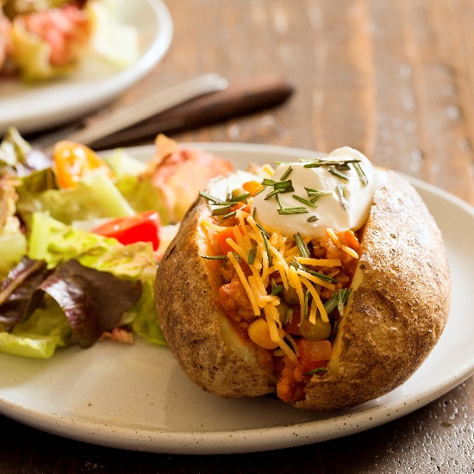
Veal Shepherd's Pie Baked Potatoes
by Carla Cardello (www.carlacardello.com)

Makes 4 servings

Prep Time: 15 minutes
Cook Time: 30 minutes
Total Time: 45 minutes

Ingredients
- 4 large russet potatoes
- Olive oil, for brushing
- 1/2 pound (8 ounces) ground veal
- 1/2 cup diced onion
- 1 large carrot, peeled and diced
- 1 garlic clove, minced
- 8 ounces canned tomato sauce (not spaghetti sauce)
- 1/2 cup beef broth
- 1/2 cup frozen peas
- 1/2 cup frozen corn
- 1 tablespoon Worcestershire sauce
- 1/2 teaspoon salt plus more for seasoning
- 1 tablespoon chopped fresh rosemary
- Shredded cheddar cheese and sour cream, for serving
Instructions
- Place the potatoes in a microwave-safe casserole dish. Prick with the tines of a fork then brush each with olive oil and sprinkle with salt. Microwave at full power for 5 minutes. Flip and microwave for another 3-5 minutes or until soft.
- Meanwhile in a large hot skillet, add the veal, onion, carrot, and a big pinch of salt. Cook until the veal is brown and no longer pink. Drain off any excess grease. Add the garlic and cook 30 seconds.
- Add the tomato sauce, broth, peas, corn, Worcestershire sauce, and salt. Bring to a boil. Turn the heat down and simmer for 10-15 minutes or until the mixture is thick and glossy, stirring often. Stir in the rosemary.
- Cut each baked potato in half. Top with veal mixture, cheese, and sour cream.
Possible Topics For The Classroom:
- Time management - cooking the veal while the potatoes are cooking
- Salting as you cook rather than waiting until the end helps bring out flavors of ingredients during cooking (e.g. natural juices from onions) as well as prevents your taste buds from being overwhelmed if added all at once.
- Frozen vegetables are just as high in nutrients and vitamins as fresh, sometimes even more since vegetables are frozen at their peak.
- Difference between simmering and boiling

