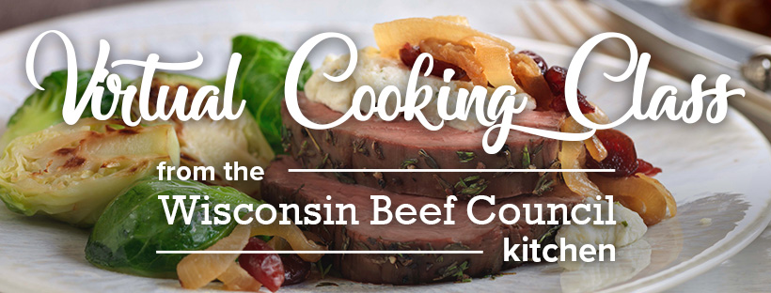

Beef Tenderloin with Wine-Braised Onions & Herb Cheese
Beef Tenderloin Roast is a special meal to serve, so you want to be sure to cook it just right. Caramelized onions and herbed cheese complement this tender and juicy cut of beef.

Recipe time: 1 Hour 15 Minutes
Makes 8 servings

INGREDIENTS:

- 1 center-cut beef Tenderloin Roast (about 2 pounds)
- 2 tablespoons fresh thyme
- 1-1/2 teaspoons regular or coarse grind pepper
- 1 package (5.2 ounces) garlic and herb soft spreadable cheese

Caramelized Onions
- 2 tablespoons butter
- 2 large yellow onions, chopped
- 1/3 cup sweetened dried cranberries or coarsely chopped tart cherries
- 1/2 teaspoon salt
- 1 cup dry white wine
Lemon-Parmesan Brussels Sprouts, (optional)
- 1 pound Brussels sprouts
- Olive oil, kosher salt and pepper
- 1 lemon
- 4 tablespoons grated Parmesan cheese

Suggested Wine Pairing (optional)
- DAOU Cabernet Sauvignon, Guigal Cotes-du-Rhone Rogue, or Georges Dubeouf Beaujolais

COOKING:

- Heat oven to 425°F.

- Combine thyme and pepper; press evenly onto all surfaces of beef Tenderloin Roast.

- Place roast on rack in shallow roasting pan. Insert oven-safe meat thermometer so tip is centered in thickest part of beef. Do not add water or cover. Roast in 425°F oven 35 to 45 minutes for medium rare; 45 to 50 minutes for medium doneness.

- For Caramelized Onions, heat butter in large nonstick skillet over medium-low heat until melted. Add onions, cranberries or cherries and salt; cook 30 to 35 minutes or until onions are very tender and golden brown, stirring often.

- Line a baking sheet with aluminum foil. Slice the Brussels sprouts in half, toss with drizzles of olive oil and pinches of salt and pepper, and spread on the baking sheet. Roast 20 to 30 minutes or until tender and golden brown around the edges.

- Toss the roasted Brussels sprouts with the zest from one lemon and juice and Parmesan cheese. Garnish with fresh thyme.

- Add wine to caramelized onions; increase heat and bring to a boil. Cook, uncovered, 3 to 5 minutes or until wine is almost evaporated, stirring occasionally. Keep warm.

- Remove roast when meat thermometer registers 135°F for medium rare; 145°F for medium. Transfer roast to carving board; tent loosely with aluminum foil. Let stand 15 to 20 minutes. (Temperature will continue to rise about 10 to 15°F to reach 145°F for medium rare; 160°F for medium.)

- Carve roast into slices; season with salt, as desired. Top slices evenly with cheese; top cheese with onions. Serve with roasted Brussels sprouts.

Nutrition information per serving: 324 Calories; 153 Calories from fat; 17g Total Fat (9 g Saturated Fat; 3 g Monounsaturated Fat;) 96 mg Cholesterol; 313 mg Sodium; 9 g Total Carbohydrate; 1.1 g Dietary Fiber; 26 g Protein; 1.9 mg Iron; 7.1 mg NE Niacin; 0.6 mg Vitamin B₆; 1.4 mcg Vitamin B₁₂; 4.6 mg Zinc; 28.3 mcg Selenium; 95.4 mg Choline. This recipe is an excellent source of Protein, Niacin, Vitamin B6, Vitamin B12, Zinc, and Selenium; and a good source of Iron, and Choline.

