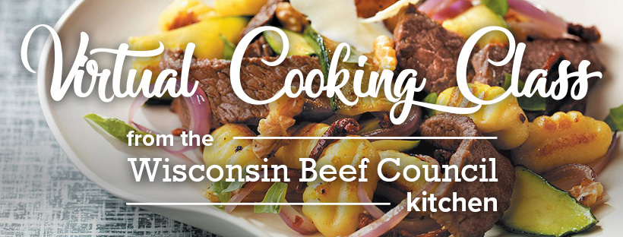

Shopping list:
Meat Department
1-pound Beef Ranch Steaks, Denver Steaks, or Top Sirloin Steak
Produce
2 small zucchini
1 small red onion
Fresh basil
Minced garlic
Julienne cut sun-dried tomatoes, packed in oil
Pantry
Olive Oil or avocado oil
1 pound shelf-stable gnocchi
Chopped walnuts OR pine nuts
Black pepper
Crushed red pepper
Dairy
Ricotta salata OR crumbled feta

Equipment needed:
- Two Large cutting boards and sharp knives
- Large nonstick skillet
- Large mixing bowl
- Measuring spoons
- Tongs, mixing spoon
- 4 serving bowls

