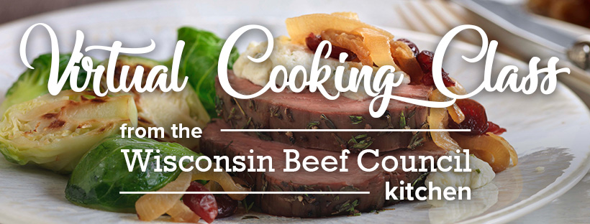

Shopping list:
Meat Department
2-pound Beef Tenderloin Roast, Choice or Select, center-cut and trimmed
Produce
Fresh thyme
2 large yellow onions
1 pound fresh Brussels sprouts
1 lemon
Pantry
Olive Oil
Kosher salt and cracked black pepper
Sweetened dried cranberries or tart cherries
Dairy
Butter
1 package (5 oz.) garlic and herb soft spreadable cheese
Parmesan Cheese, grated
Liquor
Dry white wine

Wine Pairing (optional)
DAOU Cabernet Sauvignon,
Guigal Cotes-du-Rhone Rogue
OR Georges Dubeouf Beaujolais

Equipment needed:
- Measuring spoons
- Roasting pan and rack
- Oven-safe meat thermometer
- Large nonstick skillet
- Large cutting board and sharp knife
- Tongs, mixing spoon
- Mixing bowls
- Rimmed baking sheet
- Aluminum foil
- Microplane or cheese grater
- Carving knife

