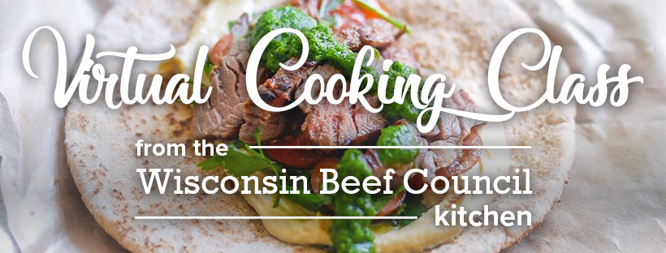

Shopping list:
Meat Department
1-1/2 pounds Flank Steak OR Top Sirloin Steak

Produce
Fresh parsley, 1 cup
Fresh basil leaves, 1 cup
Fresh oregano, ¼ cup
Minced garlic
1 jalapeno pepper
Cherry tomatoes
1 cucumber
1 large red onion
1 lemon
Deli
1 cup hummus
Dairy Section
Crumbled feta
Pantry
Salt and Pepper
Extra-virgin olive oil

Bakery
Whole wheat pita breads

Equipment needed:
- Blender or food processor
- Plastic gallon bag OR large glass dish
- Large bowl and mixing spoon
- Cutting board and sharp knives
- Measuring spoons and cups
- Micro plane and lemon juicer
- Large heavy bottomed skillet OR cast iron pan
- Instant read meat thermometer

