

Mediterranean Beef Flank Steak Pita

This steak pita recipe is everything we love about the Mediterranean diet: lean beef steak, colorful vegetables, whole grains, olive oil, healthy portion sizes, with ingredients that are fresh and vibrant! This recipe was created by Chef Dan Churchill, in partnership with Beef. It's What's For Dinner.

Total Recipe Time: 50 minutes
Makes 6 servings

- 1 beef Flank Steak (about 1-1/2 pounds) OR 1 beef Top Sirloin Steak (about 1-1/2 pounds)
- 4 whole wheat pita breads
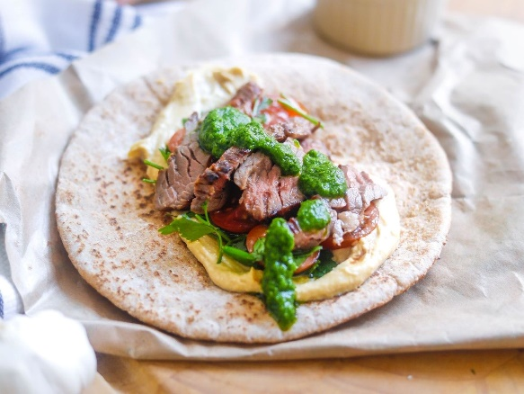
- 1 cup hummus
Spicy Green Seasoning:
- 1 cup fresh parsley, loosely packed
- 1 cup fresh basil leaves, loosely packed
- 1 teaspoon minced garlic
- 1 teaspoon minced jalapeño pepper
- 3 tablespoons olive oil
- 1/2 teaspoon salt
Cucumber Salad:
- 1/3 cup reduced-fat feta cheese crumbles
- 1 dozen cherry tomatoes, halved or sliced
- 2 cups cucumber, diced
- 1/4 cup fresh oregano, chopped
- 1-1/2 cups red onions, diced
- 1 lemon, zested and juiced
- 1 tablespoon extra-virgin olive oil
- 1/4 teaspoon salt
- 1/4 teaspoon pepper
- To prepare Spicy Green Seasoning, combine all ingredients in blender or food processor; process on and off until all ingredients are blended. Remove 2 tablespoons of Spicy Green Seasoning; rub the remaining on all sides of beef steak. Place steak in food-safe plastic bag or glass dish. Close bag securely and marinate for 20 minutes in refrigerator. Reserve the remaining seasoning for serving.
- Combine all ingredients for Cucumber Salad﻿ in large bowl; toss gently. Cover and refrigerate.
- Heat large, nonstick skillet over medium heat until hot. Remove steak from marinade; discard marinade. Place beef steak in skillet; cook 16 to 20 minutes until instant-read thermometer inserted horizontally into center registers 145°F (for medium) to 160°F (medium) doneness, turning occasionally. Remove steaks from the pan and let rest 5 minutes.

Cook's Tip: You may cook steak on a charcoal or gas grill. Remove steak from marinade; discard marinade. Place steak on grid over medium, ash-covered coals. Grill, covered, 11 to 16 minutes (over medium heat on preheated gas grill, 16 to 21 minutes) for medium rare (145°F) to medium (160°F) doneness, turning occasionally.

- Place 1/4 cup hummus on each pita; top with Cucumber Salad. Carve steak into thin slices. Top Cucumber Salad with steak; top with saved Spicy Green Seasoning.

Nutrition information per serving, 1/6 recipe: 463 Calories; 202.5 Calories from fat; 22.5g Total Fat (5.9 g Saturated Fat; 0.1 g Trans Fat; 3.1 g Polyunsaturated Fat; 11.4 g Monounsaturated Fat;) 77 mg Cholesterol; 788 mg Sodium; 30 g Total Carbohydrate; 6.1 g Dietary Fiber; 4.4 g Total Sugars; 35 g Protein; 0 g Added Sugars; 124 mg Calcium; 4.6 mg Iron; 754 mg Potassium; 0 mcg Vitamin D; 0.2 mg Riboflavin; 8.3 mg NE Niacin; 0.8 mg Vitamin B₆; 1.5 mcg Vitamin B₁₂; 354 mg Phosphorus; 6 mg Zinc; 40.7 mcg Selenium; 114.2 mg Choline.
This recipe is an excellent source of Dietary Fiber, Protein, Iron, Niacin, Vitamin B6, Vitamin B12, Phosphorus, Zinc, Selenium, and Choline; and a good source of Potassium, and Riboflavin.

