

Beef and Veggie Frittata

Add this excellent dish to any brunch (or enjoy for dinner) and wow your family and friends. It's loaded with Ground Beef, red potatoes, zucchini, tomato, and fresh basil. .

Total Recipe Time: 50 minutes
Makes 6 servings
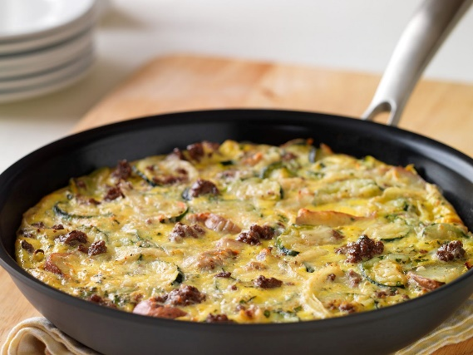
- 1 pound Ground Beef (93% lean or leaner)
- 4 small red-skinned new potatoes (about 6 ounces), cut into 6 wedges each
- 1/2 cup water
- 1 cup thinly sliced yellow onion
- 1 small zucchini, cut lengthwise in half, then crosswise into 1/4-inch-thick slices
- 1 teaspoon salt, divided
- 1/2 teaspoon pepper, divided
- 6 large eggs
- 2 tablespoons chopped fresh basil
- 3 tablespoons shredded Italian cheese blend
- 1/2 cup chopped tomato
- Heat oven to 350°F. Combine potatoes and water in 10-inch nonstick ovenproof skillet; bring to a boil. Reduce heat; cover and simmer 8 to 10 minutes or until potatoes are tender. Remove from skillet; keep warm. Pour off remaining water from skillet, if necessary.

- Brown Ground Beef with onion in same skillet over medium heat 6 minutes, breaking beef up into 3/4-inch crumbles. Add zucchini. Cook 2 to 3 minutes or until zucchini is just tender. Pour off drippings. Return potatoes to skillet. Add 1/2 teaspoon salt and 1/4 teaspoon pepper; mix thoroughly. Cook's Tip: Cooking times are for fresh or thoroughly thawed Ground Beef. Ground Beef should be cooked to an internal temperature of 160ºF. Color is not a reliable indicator of Ground Beef doneness.

- Whisk eggs, basil and remaining 1/2 teaspoon salt and 1/4 teaspoon pepper in large bowl. Pour evenly over beef mixture. Sprinkle with cheese. Bake in 350°F oven about 18 to 20 minutes or until eggs are set.

- Sprinkle frittata with tomato. Cut into 4 to 6 wedges.

Nutrition information per serving, using 93% lean ground beef: 355 Calories; 144 Calories from fat; 16g Total Fat (6 g Saturated Fat; 6 g Monounsaturated Fat;) 357 mg Cholesterol; 806 mg Sodium; 14 g Total Carbohydrate; 2.2 g Dietary Fiber; 37 g Protein; 4.7 mg Iron; 9.4 mg NE Niacin; 0.7 mg Vitamin B₆; 2.9 mcg Vitamin B₁₂; 7.3 mg Zinc; 41.6 mcg Selenium; 314.8 mg Choline. This recipe is an excellent source of Protein, Iron, Niacin, Vitamin B6, Vitamin B12, Zinc, Selenium, and Choline.

