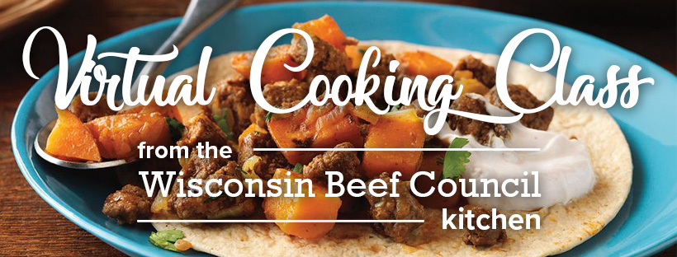

Shopping list:
Meat Department
1 pound Lean Ground Beef

Produce
1 large sweet potato
1 large yellow onion
Fresh cilantro

Pantry
1 packet taco seasoning
Vegetable oil
Hot pepper sauce
8 small corn tortillas (6 to 7 inches diameter)

Dairy
¼ cup plain nonfat Greek-style yogurt

Equipment needed:
- Large nonstick skillet and lid
- Mixing spoon or utensil to crumble ground beef
- Sharp knife
- Large cutting board
- Measuring cups and spoons
- Small bowl for yogurt sauce

Reducing Fat in Ground Beef—If you do not want to buy 96% Lean Ground Beef, you can rinse your crumbles to cut the fat content.
Equipment needed:
- 1-quart microwave safe bowl
- Slotted spoon
- Dinner plate
- Paper towels
- Mesh strainer or colander
- Second large bowl

